**ABSTRACT**  
 An efficient and smart way to automate the management of parking systems that allocates efficient parking spaces using Internet of Things (IoT) technology. IoT provides wireless access to the system, allowing users to track the availability of parking areas. With the increase in the population of vehicles in metropolitan cities, road congestion has become a major problem. The aim of this paper is to resolve this issue. Users typically waste time and effort searching for available spaces in a specified parking area. Parking information is sent to the user via notifications, minimizing the waiting time for users searching for parking spaces. RFID technology is used to avoid car theft.  
**Keywords**: RFID, Arduino, GSM Module, IR Sensor, Cloud

A Smart Parking System is an advanced solution designed to optimize the process of finding, reserving, and managing parking spaces by leveraging modern technologies such as IoT, AI, and cloud computing. Here’s an abstraction of its key components and functionality: reserving and managing parking spaces using IoT and other modern technologies.

**TABLE OF CONTENTS**

|  |  |  |
| --- | --- | --- |
| **SI.NO** | **CONTENT** | **PAGE NO** |
| 1 | Introduction | 3 |
| 2 | Methodology | 4 |
| 3 | Working of Smart Parking System | 5 |
| 4 | System Architecture | 6 |
| 5 | Details of the Model | 7-8 |
| 6 | Implementation | 9 |
| 7 | Results & Discussion | 10 |
| 8 | Conclusion & Future Work | 11 |
| 9 | References | 12 |

**INTRODUCTION:**  
 The Internet of Things (IoT) has the ability to transfer data through networks without human interaction. IoT allows users to utilize affordable wireless technology and also facilitates transferring data to the cloud. IoT helps maintain transparency and control. The idea of IoT originated from connecting various devices for monitoring or controlling through computers over the internet.  
 IoT consists of two key components: “Things.” The Internet is a vast network connecting servers to devices. It enables the transmission and reception of information, allowing devices to communicate. The parking problem contributes to air pollution and traffic congestion. In today’s scenario, finding parking space is a challenge for many people. According to a survey, the vehicle population is expected to increase to over 1.5 billion by 2035. Around one million barrels of oil are burned globally every day. Therefore, a smart parking system is a key solution to reduce fuel waste. This paper proposes a solution for the challenges caused by parking issues.  
 Smart parking is a solution to minimize users’ time and improve efficiency, as well as reduce the overall fuel consumption in search of parking. Data is collected from sensors and processed to produce an

**METHODOLOGY AND METHODS:**

1. The sensors in the IoT-based smart parking system store and access data from remote locations via the cloud. This creates a Cloud of Things (COT). The system allows for monitoring and controlling the nodes from any location. The system provides information on the availability of parking slots through a mobile application, which can be accessed remotely by users.
2. An algorithm is used to improve the efficiency of the cloud-based parking system, and network architecture technology helps in finding the lowest-cost parking space.
3. Wireless sensor nodes and smartphone applications are used to detect available parking spaces. Since wireless technology is employed, the system provides high accuracy and efficiency.
4. In this system, onboard units enable communication between vehicles. When a user parks their vehicle in one of the available bays, a mechanical lift lifts the vehicle.

**RELATED WORKING OF SMART PARKING SYSTEM:**

1. Sensors in IoT-based smart parking systems store and access data remotely using cloud technologies, which forms the Cloud of Things (COT).
2. An algorithm enhances the efficiency of cloud-based parking systems, while network architecture technology helps to identify the lowest-cost parking space.
3. Wireless sensor nodes, along with smartphone applications, are used to detect parking spaces. This approach ensures high accuracy and efficiency due to wireless technology.
4. In a survey of smart parking systems, the author categorized detector systems and vehicle sensors into two groups: intrusive and non-intrusive sensors.
5. A paper proposes an efficient solution to address parking availability in real-time scenarios and reduce time consumption. In this system, data is sent locally to devices that filter the information. This data is then transmitted over the cloud for processing and evaluation, using machine learning algorithms. A mobile phone application connects users with real-time traffic status via Google API, thus avoiding traffic congestion. However, this paper does not offer a parking reservation feature.

**SYSTEM ARCHITECTURE:**  
 A. **Proposed System**:  
 It consists of three main sections:

1. **Parking Area**: This includes Arduino devices and an IR sensor. The user interacts with the parking area using these devices. The user cannot enter the parking area without an RFID card.
2. **Cloud-Based Web Services**: Acts as a mediator between the user and the parking area. The cloud is updated based on the availability of parking spaces. The admin manages the cloud services, which users can access to check availability.
3. **User Side**: The user receives notifications based on the availability of parking spaces via a mobile application.

|  |  |
| --- | --- |
|  |  |
|  |  |

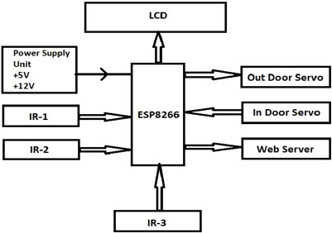

**DETAILS OF THE MODULE:**

**A**. **GSM Module**:  
 The GSM module is used to establish communication between mobile phones and the . It enables sending SMS, MMS, and voice messages through a mobile network. The GPRS extension in GSM supports high data transmission rates. GSM employs Time Division Multiple Access (TDMA) for transmission.

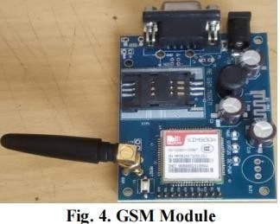

**B.** **IR Sensor**:  
 An infrared sensor detects the presence of objects by emitting infrared light. If no light is reflected back, there is no object present. If light is detected, it indicates the presence of an object.

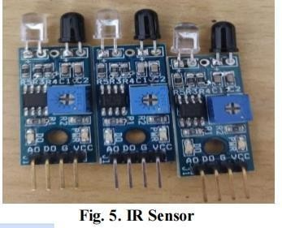

**C**. **Servo Motor**:  
 A servo motor is a rotary device used to control angular and linear motion. It is used for the opening and closing of gates. The servo driver sends electrical signals to the servo motor to produce motion.

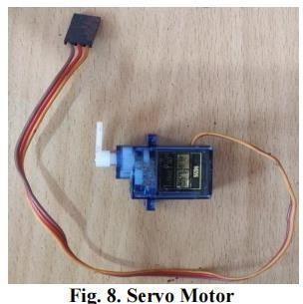  
D. **Arduino Nano**:  
 The Arduino Nano is a compact board used in various devices and fields. It features 22 input/output pins, of which 14 are digital. It has 32 KB of flash memory. These pins control both digital and analog operations. This module is breadboard-friendly.

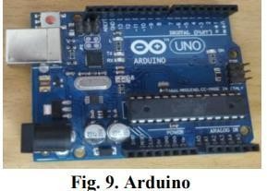

**IMPLEMENTATION:**  
 This section describes the implementation of the proposed system. Every user entering the parking slot has an RFID card containing their details. When the RFID card is scanned by the reader module, the user’s details are transferred to the module. The IR sensor checks whether the parking space is available. If there is no space, the parking barrier gate will not open. A message is sent to the user via the GSM module, depending on whether the space is available or not. The Wi-Fi module supports the system by storing all data in the cloud, which connects the devices to the cloud server.

**Message Received by User**:

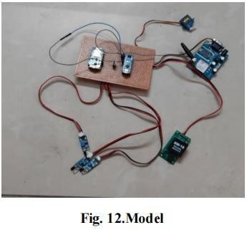

The user scans the RFID card provided. If space is available, the user receives a message saying, “Welcome, [username].” The barrier gate opens, and the user can park their car. When the user exits, the RFID card is scanned again, and the user receives a message: “Thanks for using smart parking, [username].” The database is updated with the user’s activity in the parking space.

**RESULTS & DISCUSSION:**  
 The demand for smart parking systems is growing significantly. These systems enable users to access real-time availability of parking spaces. Existing systems do not include parking reservation facilities or slot availability checkers. The previous systems included vision-based monitoring systems, which estimated the number of available parking slots by counting the number of incoming and outgoing cars. This method consumed a lot of time and effort. The next system was a sensor-based system that used ultrasonic sound waves to detect vehicle presence. Additionally, two-tier parking systems were introduced, which use stacked parking arrangements. This paper proposes a system that connects parking areas to the world, reduces time, and is cost-effective for users. Moreover, this paper addresses the issue of car theft and reduces overall fuel consumption.

**CONCLUSION & FUTURE WORK:**  
 The concept of smart cities has long been a dream. Recent advancements have made this dream more achievable. The development of IoT and cloud technologies plays a vital role in building smart cities. Smart parking is a core component of such cities. This system provides real-time updates about parking slots, helping save users’ time and resolving traffic congestion. Future work could include allowing users to reserve parking spaces remotely using GPS technology for further optimization.

**REFERENCES:**

1. Abhirup Khanna, R. A. (2016). IoT-based Smart Parking System. International Conference on Internet of Things and Applications (IOTA) (p. 5). Pune: IEEE.
2. Deng, D. (2015). A Cloud-Based Smart Parking System Based on Internet-of-Things Technologies. IEEE, 11.
3. O. Orrie, B. S. (2015). A Wireless Smart Parking System. IECON (p. 5). Yokohama: IEEE.
4. Khaoula Hassoune, W. D. (2016). Smart Parking Systems: A Survey. IEEE.
5. Wael Alsafery, B. A. (2018). Smart Car Parking System Solution for the Internet of Things in Smart Cities. IEEE.
6. Rachapol Lookmuang, K. N. (2018). Smart Parking Using IoT.